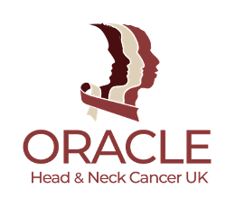

Oracle Head & Neck Cancer UK: Expert Review Process
Oracle uses a rigorous, independent expert review process to guide all research funding decisions. This process reflects best practice and adheres to the Association of Medical Research Charities (AMRC) Principles of Expert Review.

Key features of our process:
- Independent Research & Funding Committee: Comprised of clinicians, researchers, and a patient representative—none of whom receive funding from Oracle.
- Two in-depth reviews per application: All proposals are assessed by at least two independent reviewers.
- Diversity of input: Committee members bring experience from different disciplines, geographies, and stages of career. We also involve external reviewers where extra expertise or capacity is needed.
- Patient and Public Involvement (PPI): A patient voice is built into every stage of our strategy and funding decisions.
- Transparent scoring: We use a structured 36-point matrix with criteria covering strategic fit, impact, methodology, PPI, and return on investment.
- Final decisions: Made based on combined reviewer scores, committee discussion, and applicant clarifications.

Animal research
We are open to funding animal research but require applicants to describe how they apply the 3Rs (Replacement, Refinement, Reduction). Applications involving higher species (e.g. primates, cats, dogs) are subject to heightened scrutiny.
Oracle is committed to ensuring our review process is fair, inclusive, evidence-based, and aligned with AMRC guidance. Please see this policy here: https://www.amrc.org.uk/Listing/Category/the-use-of-animals-in-research
Oracle strongly supports the AMRC’s position statement on the use of animals in research and any projects we fund that include use of animals must be conducted in line with the 3Rs. We ensure this through expert review and by promoting the 3Rs in our terms and conditions.
[Read more about how we fund research.]

